WOODBURY HEIGHTS POLICE DEPARTMENT
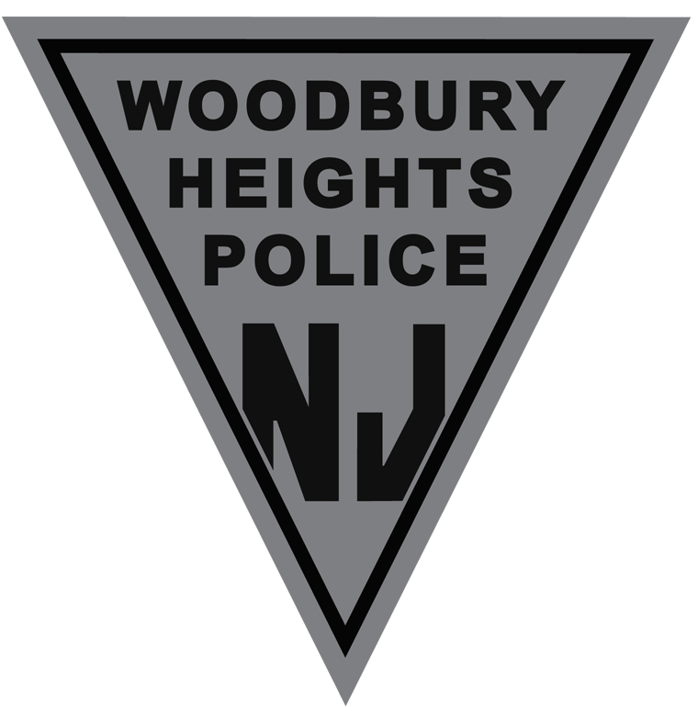
500 ELM AVENUE
WOODBURY HEIGHTS, NJ 08097

JOSHUA M. MOLINE TELEPHONE NUMBER: (856)848-6707
CHIEF OF POLICE EMERGENCY CALL 911
NON-EMERGENCY: (856)589-0911
FAX: (856)853-2995

Employment Opportunity

The Woodbury Heights Police Department is currently accepting applications for Class Three Special Police Officers for Gateway Regional High School for the upcoming 2019-2020 school year.

Requirements:
• Must be a retired police officer who has previously served as a duly qualified, fully-trained, fulltime officer in any municipality or county of this state, or as a member of the New Jersey State Police, and must be living in New Jersey.
• Must be retired from that agency in good standing and submit a letter from that agency indicating that the retirement was in good standing and the date and type of retirement.
• Must be less than 65 years of age at appointment
• Must pass a psychological exam.
• Must pass a drug test pursuant to Attorney General’s Law Enforcement Drug Testing Policy
• Must pass an updated background application.
• Must have retired within three years from date of appointment as Class 3 officer.
• Must be able to read and write the English language.
• Must have a valid NJ driver’s license.
• Not have been convicted of any violations of laws of the State of New Jersey or the United Stated, except minor traffic offenses, nor shall have been convicted of any crime or offense involving moral turpitude.

Starting salary for the Class III Special Officer shall be $28 per hour and they shall work a schedule of approximately 40 hours a week. The officer shall only work when school is in session. The Special Officer shall conduct school safety and security duties within Gateway Regional High School.

Interested applicants can email a resume to the attention of Chief Josh Moline at jmoline@whpdnj.com Application deadline is Friday, August 16th, 2019 at 4pm.

Woodbury Heights is an Equal Opportunity Employer

