**City of New Britain PSTC**

10 Chestnut Street

New Britain, CT 06051

**9-1-1 Saves Lives**

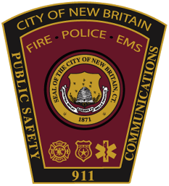

**PUBLIC SAFETY TELECOMMUNICATIONS CENTER**

The City of New Britain is currently seeking applications for:

**Public Safety Telecommunicator Apprentice Program**

**SALARY:** $24.07 hourly (Part Time)

**DEPARTMENT:** Public Safety Telecommunications Center

**PROGRAM OVERVIEW:**

A unique opportunity to explore a career in Public Safety Telecommunications through participation in a performance based, on the job, introductory Telecommunicator training program. Candidates will be trained on a subset of call taking and dispatching skills that must be demonstrated while processing New Britain Police, Fire and EMS calls for service. Training is a phased approach whereby each candidate must successfully complete one phase before moving to the next. Phases are call taking, Fire/EMS dispatching and Police dispatching. Failure to complete a phase will result in release from the program. A minimum weekly commitment of 16 - 24 hours is required over an approximate 10 week period. Candidates will be considered successful after demonstrating the required phase specific skills in an accurate, timely and efficient manner. Upon completing the program, candidates will be offered full time employment and continue on the job training.

**MINIMUM QUALIFICATIONS:**

Graduation from high school. Proven history of responsible actions, effective communications skills, and ability to type 25 words per minute, ability to multi-task in a stressful environment, and availability to work day, evening and midnight shifts. A second language and prior telecommunications or public safety experience desired.