Thank you for your interest in the position of police officer with the South Burlington Police Department. We extend a special opportunity for you to pursue a challenging and rewarding career in law enforcement with one of the best police agencies in the State of Vermont

The South Burlington Police Department is a progressive police agency whose officers are dedicated to providing its residents with the best in policing service. Our department holds a promising future for individuals who are genuinely interested in a challenging career in policing.

We encourage prospective employees to visit South Burlington and the Champlain Valley in Vermont. The quality of life in this area is outstanding; our community is friendly and supportive; recreational activities are plentiful; and there are amenities and activities available that are similar to a larger community with a small town feeling. Come and visit the area for a couple of days, schedule a ride-a-long with our agency and decide for yourself.

If you have any questions at all or feel you need additional information, please feel free to contact us.

South Burlington Police Department
19 Gregory Drive
South Burlington, VT 05403
(802) 846-4165

EMAIL: Recruiting@SBPDVT.org
WEBSITE: www.sbpdvt.org

AGENCY PROFILE

The City of South Burlington is located on Lake Champlain in Chittenden County and is a suburb of Burlington, Vermont. South Burlington was incorporated in 1971 and has an estimated population of 19,000. The city’s economic base includes light manufacturing industries, retail and commercial establishments, hotels, restaurants, and residential land uses. The area surrounding the city is still rural farmland, but is slowly being developed. The presence of the Burlington International Airport in South Burlington is of significance as a major industry; however, the City of South Burlington does not provide law enforcement services for the airport.

The City of South Burlington, Vermont has a Council and City Manager form of government. The city employs approximately one hundred ten (110) people and provides traditional services including police, fire, EMS, planning, zoning, public works and recreation. Property tax, Local Option tax, and water service billing provide the city with operational revenues.

The South Burlington Police Department has forty (38) sworn officer positions authorized and (7) full time civilian employees. The agency is organized into three divisions; Administrative Services Division, Prevention Services Division, Support Services Division. The Administrative Services Division is managed by a Captain and is responsible for the personnel, planning, research, records, accounting, confidential funds and internal affairs functions. The Prevention Services Division is managed by a Lieutenant and is responsible for the patrol and traffic safety functions. The Support Services Division is managed by a Lieutenant and is responsible for the communications, fleet maintenance, uniforms, supplies, youth services/crime prevention functions, criminal investigations and property management functions.

The South Burlington Police Department is a progressive policing agency, noted throughout the police community for its “firsts”. We were the first Vermont agency to have DARE in our schools, first agency with computer aided dispatching and first in the state to achieve CALEA accreditation. That tradition continues here today. If you want to be on the leading edge of Policing in the State of Vermont, this is the place for you!
Police Officer

Officers perform their policing duties in daily assigned areas for the purposes of crime prevention, problem solving, and law enforcement. We encourage a community based approach to reducing crime and increasing the quality of life for our community. The duties our officers perform include, but are not limited to: crime investigation; identification/apprehension of offenders; traffic enforcement; crash investigation; community involvement/problem solving; and the general delivery of police services that are aimed at our mission statement.

Applicants must meet the following requirements:

- Must be 20 years old at time of application; and
- Must have obtained a high school diploma, however, preference is given to those having a minimum of an Associated Degree from and accredited college or university; or
- Who are already full-time certified as a police officer with two or more years of full-time police experience, or who have served honorably in any branch of the military services for a minimum of two years
Applicants who meet the minimum requirements are selected on a competitive basis. Applicants must successfully complete each of the following elements of the selection process before being considered as an employee for this agency:
- Written exam for entrance to the Vermont Police Academy (if not already taken or certified)
- Physical fitness test for entrance to the Vermont Police Academy (if not already taken or certified)
- Psychological test (if not already taken)
- Oral board interview
- Thorough background investigation & Interview with Chief of Police and City Manager
- Complete medical examination (post conditional offer)
Benefits for officers include:
- Competitive starting salary, plus shift differential | - Fixed annual shifts bid once per year based on seniority
- Life/Liability/Dental Insurance | - Retirement Plan currently at 25 years of service & age 53 (age being dropped to age 50 in 2011)
- Educational reimbursement | - Uniforms/equipment provided plus small equipment allowance
- Numerous paid holidays plus paid vacation | - Uniform cleaning
- Paid sick leave accumulation | - Health insurance w/small employee contribution
- Specialized training and assignment opportunities | - Short term disability

The South Burlington Police Department actively seeks a diverse and multi-cultural workforce. We encourage women and minorities to apply for our open positions. Applications can be obtained by contacting our office or by visiting our website at www.sbpdvt.org:
The South Burlington Police Department is an equal opportunity/affirmative action employer.

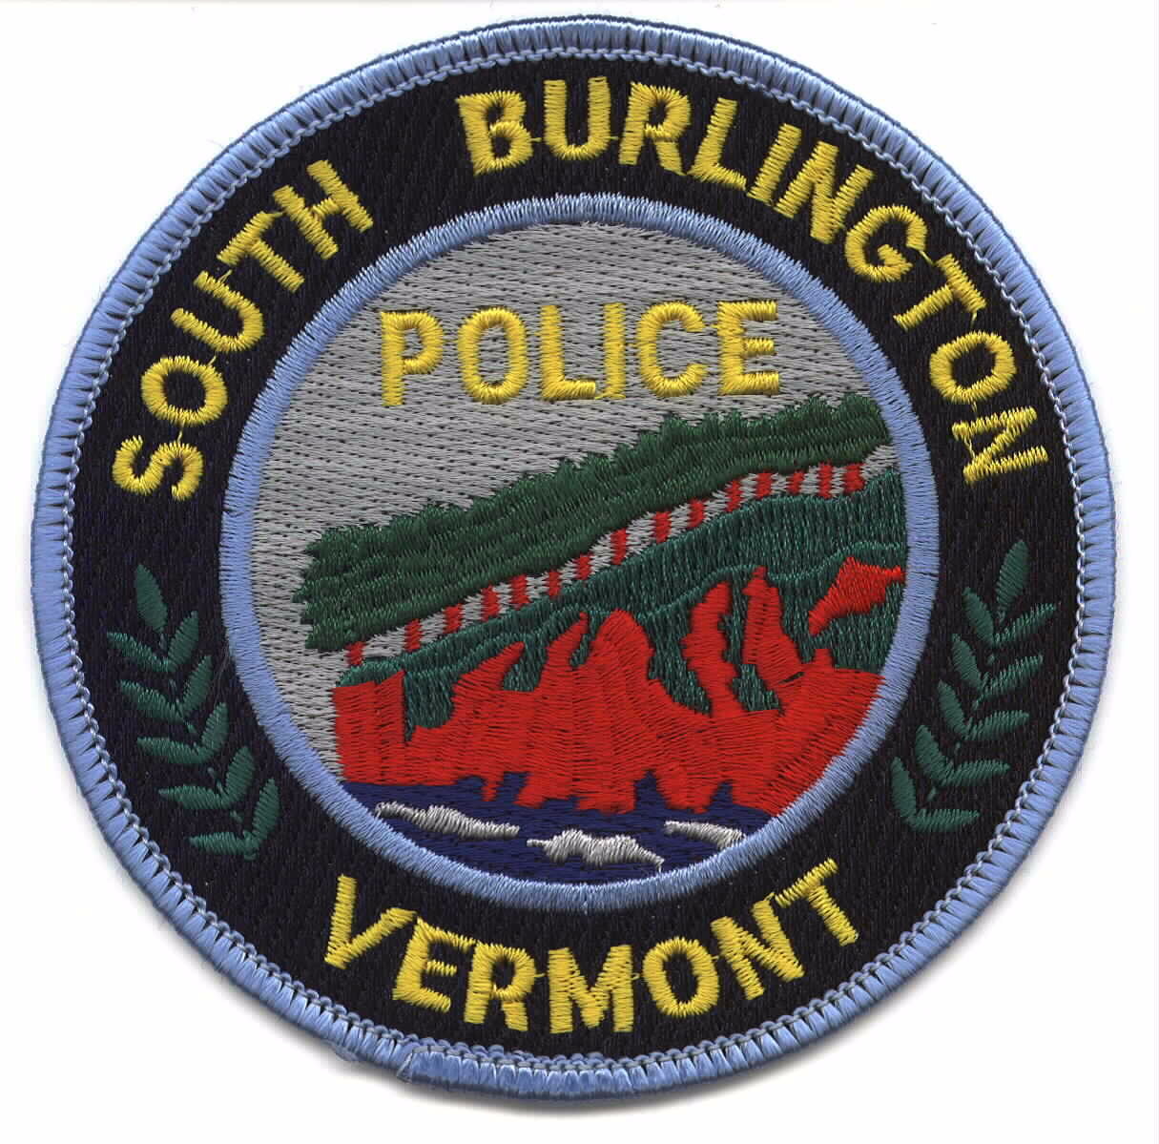
SOUTH BURLINGTON POLICE DEPARTMENT
Employment Application

This form was constructed with Microsoft Word 2010 and saved to be compatible with previous versions.
You may complete this application and email it to:
recruiting@sbpdvt.org

Position Applying For:

NAME:
Street Address:
City: State: Zip Code:
Date of Birth:
Email Address: Telephone #’s: Home: Cell:

- Are you a United States Citizen? Yes No
If not, can you provide proof that you are legally allowed to work in the U.S.?: Yes No
- Do you have a motor vehicle conviction record? Yes No
If yes, please specify:
- Do you have a criminal conviction record: Yes No
If yes, please specify:
- Do you have a valid Vermont Driver’s license? Yes No
What is your Drivers License Number?
- Do you own a car? Yes No
Registration (License Plate) Number:
- Have you ever been involved in a motor vehicle accident that resulted in property damage, personal injury or death? Yes No
Please Explain:
- Are you an employee or an official of any state, territory, county or municipality? Yes No
Where and for whom?
- Have you ever been discharged (fired) from employment for any reason? Yes No
Please explain?
- Have you ever resigned after being informed that your employer intended to discharge you?
Yes No
From where?
- List of residence addresses for past ten year, including length of time and dates of each:
1.
2.
3.
4.

- Previous employment: (List last three (3) places of employment)
  - Dates of employment (month and year) from to
Exact title of your position
Salary or earnings (starting) $ per
(final) $ per
Name and address of employer (firm, organization, etc.)
Name of Employer:
Place of employment: City: State:
Name and title of immediate supervisor :
Reason for leaving:
Description of work:

  - Dates of employment (month and year) from to
Exact title of your position
Salary or earnings (starting) $ per
(final) $ per
Name and address of employer (firm, organization, etc.)
Name of Employer:
Place of employment: City: State:
Name and title of immediate supervisor:
Reason for leaving:
Description of work:

  - Dates of employment (month and year) from to
Exact title of your position
Salary or earnings (starting) $ per
(final) $ per
Name and address of employer (firm, organization, etc.)
Name of Employer:
Place of employment: City: State:
Name and title of immediate supervisor:
Reason for leaving:
Description of work:
- Education:
  - Name of Grade School :
  - Name of High School:
Diploma Received: Yes No GED: Yes No
  - Name of College/University (Undergraduate):
# of years attended:
Type of Degree Received:
Major:
  - Name of College/University (Graduate):
# of years attended:
Type of Degree Received:
Major:
- List any school in addition to above and period in attendance Include correspondence courses, night school, trade schools and similar education. Include service school in the armed forces or Merchant Marine.
- List and describe hobbies:
- Have you had any experience in commercial photography or advanced work in photography?
Yes No
- Can you swim? Excellent Good Fair
- Special skills:
  - Describe skill(s):
  - Are there associated licenses/certificates/etc., if so please describe?
  - State or other licensing authority
  - Year of first license or certificate
  - Year of latest license or certificate
- Do you have experience in the use of:
  - Computers: Yes No
Proficiency: Expert Intermediate Moderate Basic
  - Short wave or other radio: Yes No
Proficiency: Expert Intermediate Moderate Basic
  - Other: Please describe equipment: Special skills you possess and machines and equipment you can use :
Proficiency: Expert Intermediate Moderate Basic
  - Typing? Yes No Estimated words per minute
- Special qualifications not covered in application: (example: publication, patents, inventions, public speaking experience, membership in professional or scientific associations, honors or fellowships received.)
- If applying for a Police Officer Position, have you previously tested for entrance to the Vermont Police Academy? YES NO
  - If yes, approximately when and for what police agency?

- Did you take the Psychological (MMPI) test? Yes No

NOTE: A FALSE OR DISHONEST ANSWER TO ANY QUESTION IN THIS APPLICATION MAY BE GROUNDS FOR RATING YOU INELIGIBLE OR FOR DISMISSING YOU AFTER APPLICATION EMPLOYMENT APPOINTMENT. ALL STATEMENTS MADE IN THIS APPLICATION ARE SUBJECT TO INVESTIGATION, INCLUDING A CHECK OR YOUR FINGERPRINTS, POLICE RECORDS AND FORMER EMPLOYERS.
I certify that all of the statements made in this application are true, complete and correct to the best if my knowledge and belief, and are made in good faith.
Date:
Signature of Applicant:
(Type Name as your signature)

Recruitment Survey Questionnaire

Notice:
The South Burlington Police Department attempts to collect data from all applicants as part of National Accreditation Standards and for Federal Reporting. Each applicant must keep in mind that completing this section of the application is completely voluntary and you are not required to answer any or all of the questions below. Answering questions below will not affect the outcome of this application in any way. The answers are being collected for statistical purposes only.
Thank You

Gender Information: Male Female
Race: Caucasian
African/American
Native American
Asian/Pacific Islander
Other Race (please specify) _______________________________________
Hispanic: Yes No

How did you find out about our department’s opening:

Self Initiated
Radio
Television
Newspaper Ad
Magazine Ad
Internet
Friend
Relative
Relative working at SBPD
Friend working at SBPD
College
Other (please specify) ______________________________________________________

SOUTH BURLINGTON POLICE DEPARTMENT
Authority for Release of Information
I hereby authorize any investigator or duly accredited representative of the Police Department bearing this release, or a copy thereof, within one year of its date, to obtain any information from schools, residential management agents, employers, criminal justice agencies, or individuals, relating to my activities. This information may include, but is not limited to academic, residential, achievement, performance, attendance, personal history, disciplinary, arrest, and conviction records. I hereby direct you to release such information upon request of the bearer. I understand that the information released is for official use by the Police Department and may be disclosed to such third parties as necessary in the fulfillment of official responsibilities.
I hereby release any individual, including record custodians, from any and all liability for damages of whatever kind or nature which may at any time result to me on account of compliance, or any attempts to comply, with this authorization. Should there be any question as to the validity of this release, you may contact me as indicated below.
SIGNATURE (full name):
(By completing the signature box electronically, I acknowledge that I am signing in agreement to the above listed release language.)
FULL NAME:
OTHER NAMES USED (include maiden name):
DATE OF BIRTH:
CURRENT ADDRESS:
TELEPHONE NUMBER: DATE:

