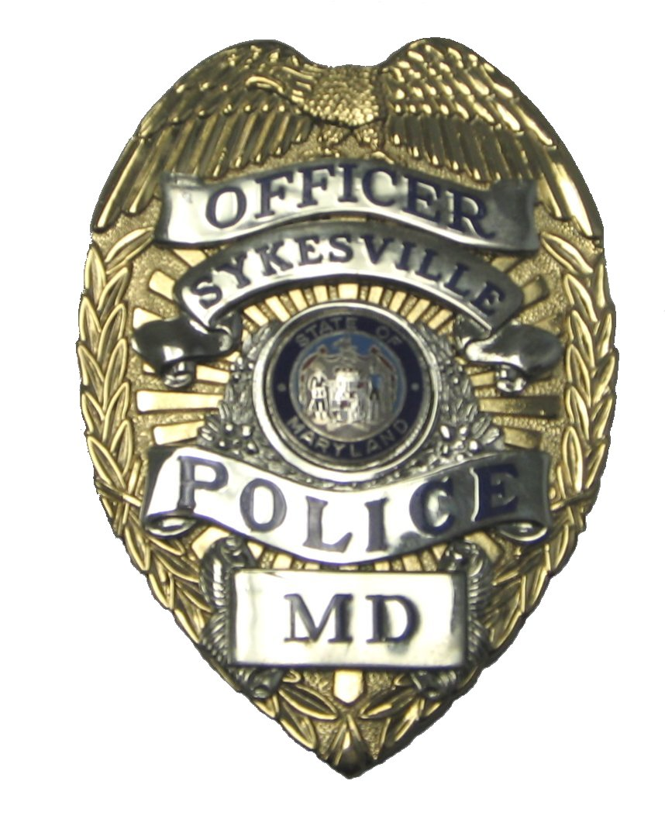
Sykesville Police Department
7547 Main Street Michael A. Spaulding
Sykesville, Maryland 21784 Chief of Police

Phone: (410) 795-0757
Fax: (410) 795-8864 www.sykesvillepolice.org

TOWN OF SYKESVILLE
JOB DESCRIPTION

Probationary Police Officer / Police Officer (Certified)
Sykesville Police Department

Job Summary:
Performs a variety of police duties essential to the preservation of law and order in the Town of Sykesville; ensures public safety, controls traffic and responds to calls for service; Employs the concepts of Community Policing on a daily basis; performs other duties as assigned.

Essential Functions:
(Functions listed are intended only as illustrations of the various types of work performed. The omission of specific duties does not exclude them from the position if the work is similar, related or a logical assignment to the position.)

- Patrols assigned residential and business sections of the Town via patrol car, bicycle or on foot, to ensure preservation of law and order;
- Maintains vigilance for infractions of criminal and motor vehicle laws and compliance with prescribed ordinances, employing appropriate measures to maintain peace and prevent criminal acts;
- Investigates reports of violation of Town, County, State and Federal laws, regulations and ordinances;
- Conducts investigations of crimes and accidents, as required;
- Collects and preserves evidence, both photographic and physical; interviews witnesses and interrogates suspects; notifies specialty units or divisions as deemed necessary;
- Serves warrants, issues summonses, juvenile complaints; makes arrests as necessary, observing the rules of safety and self-protection, using minimum force necessary;
- Responds to domestic assaults and other disturbances, employing adequate and necessary measures;
- Prepares reports as required by departmental regulations after making diligent inquiry and assuring that the reports are truthful and concise;
- Testifies in Juvenile Court, District Court, Circuit Court and before the Grand Jury regarding traffic violations and criminal investigations;
- Monitors police radio and telephone communications, receives and transmits messages relating to public safety matters;
- Ensures orderly conduct of public gatherings and meetings;
- Provides escort for persons requiring special protection or assistance;
- Directs vehicular and pedestrian traffic to ensure safety and preclude congestion of Town thoroughfares;
- Checks Town Parks for public safety and criminal violations;
- Operates radar/laser unit and testifies to its operation in courts of law;
- Administers blood alcohol tests and prepares reports pertaining thereto.
- Participates in an active public relations program;
- Cooperates with members of other law enforcement agencies upon request, within the scope of departmental practices;
- Keeps supervisor informed of unusual or detrimental situations;
- Maintains positive relationships with Town staff and the public;
- Keeps informed on current department practices by attending workshops and educational programs or reading specialized literature; and
- Performs other duties as assigned.

Required Knowledge, Skills, and Abilities:
The employee is expected to perform or possess the following:

- Thorough knowledge of the Town of Sykesville’s policies and procedures;
- Act as a representative of the Town of Sykesville to the public;
- Working knowledge of Federal, State, County, Town and departmental rules, laws, regulations, ordinances, policies and procedures pertinent to police work;
- Understand and interpret written and oral instructions;
- Thorough knowledge of traffic laws and rules governing the parking of motor vehicles and other laws, regulations, ordinances, policies and procedures pertinent to the assigned police work;
- Certified skill and ability to safely and effectively use prescribed weapons;
- Proficient in preparing accurate and timely reports;
- Keep relevant parties informed of major issues and recommend changes as appropriate;
- Operate standard police equipment, including police radio and relevant computer systems, including hardware, software and office machines.

The above job description is not intended as, nor should it be construed as, exhaustive of all responsibilities, skills, efforts, or working conditions associated with this job.

