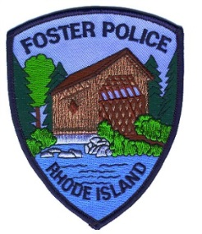
FOSTER POLICE DEPARTMENT
182 Howard Hill Rd
Foster, Rhode Island 02825
Phone # 401-397-3317 Fax# 401-397-8731
Chief William J. Ziehl

FITNESS TEST MEDICAL CERTIFICATE

Dear Physician:

The following named individual has submitted an application to become a Police Officer with the Foster Police Department.

Candidate Name: ____________________________________ Date of Birth: _____________________

Address: ___________________________________Town/City: ______________________State:_________

The Foster Police Department and the Rhode Island Department of Public Safety/Municipal Police Training Academy (RIDPS/MPTA) requires each candidate to bring a completed Physical Fitness Test Certificate to the Physical Fitness Test before he/she will be allowed to participate in the test. A statement must be obtained from a licensed physician that the candidate is of sufficient physical conditioning to undergo a Physical Fitness test. The Fitness Test Medical Certificate must be completed within six (6) months of the Physical Fitness testing date.
Attached to this form is a listing of the minimum physical fitness standards a candidate must attain. We ask that your evaluation be based upon these criteria. Thank you for your assistance.

PHYSICIAN’S STATEMENT
I have examined the above-named individual on _________________________.
(Date)
After reviewing each of the four (4) events, I find him/her to be of sufficient physical conditioning to allow the candidate to participate in the Foster Police Department and RIDPS/MPTA Physical Fitness Test.

Comments (if any): ______________________________________________________

______________________________
Physician’s Signature

(Please type or print :)
Physician’s Name: ________________________________________
Address: _________________________________________________
Telephone Number: __________________________________________________

