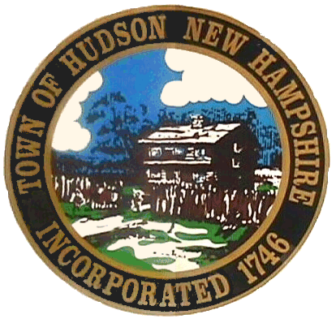
HUDSON POLICE DEPARTMENT
A Nationally Accredited Agency

Job Announcement:
POLICE OFFICER
Position(s) Available

Applications are being accepted for the position of full time Police Officer. Join a progressive law enforcement agency that embraces the philosophy of community policing. We currently employ 51 full-time police officers, including Patrol, Motorcycle, Mountain Bike Unit, K9 Unit, Evidence Collection Team, Traffic Accident Reconstruction, Detective Division, School Resource Officers and Special Operations Unit. We offer a modern facility, excellent equipment and training, NH State 25 year retirement plan, a comprehensive medical and dental plan, and earned time. In addition, we offer 11 paid holidays, and an annual educational incentive.

Effective: July 01, 2023 Salary - $60,660.64
** Includes 11 paid holidays**

A written examination for the position of full time Police Officer will be held on Thursday, June 15, 2023 @ 5:00 PM. Applications can be obtained at www.policeapp.com/HudsonNH. Deadline Monday, June 13, 2023.

If you have any further inquiries, please contact Master Patrol Officer Ron Cloutier (rcloutier@HudsonNH.Gov), Support Services/Training Division at (603) 816-2272.

THE HUDSON POLICE DEPARTMENT IS AN EQUAL OPPORTUNITY EMPLOYER. We will not discriminate because of the age, sex, race, color, marital status, physical or mental disability, religious creed, or national origin of any individual, to refuse to hire or employ or to bar or to discharge from employment such individual or to discriminate against such individual in compensation or in terms, conditions or privileges of employment, unless based upon a bona fide occupational qualification. In addition, no person shall be denied the benefit of the rights afforded by this paragraph on account of that person's sexual orientation.

