



PoliceApp.com Solution Overview
Prepared by:
Michael Quadrato
Business Development Director-PoliceApp
Michael@PoliceApp.com
203-350-2006

*This document, and any attachments thereto, regardless of form or medium is intended only for use by the addressee(s) and may contain legally provided and or/confidential, copyrighted, trademarked patented or otherwise restricted information viewable by the intended recipient only. In no event shall this document be delivered, shared or shown to any other party.

PoliceApp.com is NOT:  - Just a Job Board  - Just an Applicant Tracking System  - Just a Marketing Agency  - Just a Vendor | PoliceApp.com IS:  - Your recruitment Partner! Helping you save time, money and resources with ALL aspects of your process.

Promotion
PoliceApp.com will leverage the power of social media; including Facebook, and Twitter to announce open positions and upcoming deadlines. We also produce targeted email campaigns to our existing applicant data base and compile an interest capture email list. Also Included:
- Recruitment Lead Management (RLM)
To assist you with your local recruitment, the Recruitment Lead Management tool allows you to collect and manage prospective applicant leads from career fairs and other local recruitment efforts. RLM enables departments to evaluate their ROI on these events, and re-allocated resources and funds where they provide the greatest return.
- Department Spotlight
A static posting can only tell an applicant so much. If you want to give applicants a better understanding of what it’s really like to work for your department, as well as what duties and expectations they’ll be required to fulfill, PoliceApp.com will create a department spotlight. Department spotlights allow perspective applicants to hear directly from existing staff members, leading to a better informed and more serious applicant pool.
- Virtual Career Fair
Career fairs can be expensive and aren’t always productive. Our live virtual recruitment fair lets you speak directly to potential applicants to market your department without geographic limitations. This event is scheduled, promoted and moderated by PoliceApp.com. It is an interactive event allowing potential applicants to ask question and hear responses directly from the agency. This is a great way to reach qualified military members who are currently deployed.
A 4X10 Newspaper Ad can cost from $2,200 to $5,600- PER DAY!
Departments using PoliceApp see an increase of 30%-50% in application pools and pay $0 for our outbound marketing.

Applicant Tracking
Our applicant tracking system is where the rubber meets the road. Applicant tracking provides a significant cost saving to departments, complete with scheduling, management and other tools needed to streamline your process.
- Eliminates data entry and errors
- Significant reduction in administrative, and clerical hours by up to 70%
- Eliminate printing costs & paperwork
- Reduction in the time and resources it takes to manage a recruitment process.
Candidate Communications
Throughout the application process, PoliceApp.com relies on the modern means of communication required by today’s applicants, rather than old-fashioned snail mail. You can quickly communicate with candidates within their online PoliceApp.com account, through email and text alerts. Templates can be quickly created by any authorized users, making communication a breeze!
By increasing communication with candidates, you help keep them informed, thereby reducing calls and emails from eager applicants. In addition, keeping candidates engaged in the process will reduce loss of interest with your agency.
Background/PHQ Process
PoliceApp.com offers a tiered application approach. First, applicants can complete an initial screening application. Built in self selection tools help applicants determine if they qualify for the job as they complete the applications. This approach helps improve the quality of your applicants by discouraging individuals who do not meet your pre-requisites. Department flagging allows agencies to quickly screen submitted applications by providing feedback based on how applicants answered key questions.
Once applicants have been screened through various phases of the process, qualified applicants are invited to complete a more comprehensive PHQ or Background package.
Tracking and managing the background process all in one system, eliminates multiple islands of technology keeping authorized staff organized and informed. Checklists and reports can be specifically designed for the background process.
Don’t lose out on a good candidate with slow process!
Departments take an average of 8-11 months to complete screening and training for new officers!
The Odessa, Texas Police Department took 103 days on their background alone!
Departments using PoliceApp report an average of 70% in time savings throughout the recruitment process while decreasing the amount of time I take to process an applicant.

Reporting
A comprehensive report interface is included along with EEOC and ADA compliance that can also be generated by hiring phases. Custom reports that may be needed are also available upon request. Most custom reports are available within 48 business hours.
Data Storage/Record Retention
All data is stored and maintained in the system electronically for however long your state or local laws require. Archived files are easily accessed when needed by authorized personal.
Implementation
PoliceApp.com is ready to go out of the box! Requiring minimal impact on your department’s resources All setup is performed by PoliceApp.com. Agencies can be accepting applications in less than 48 hours with no hardware or licensing requirements.
Training/Support
The system is extremely intuitive and uses a work flow that makes sense for public safety recruitment, resulting in a minimal learning curve for users. Ongoing remote support and training is provided at no additional cost.
Applicant and department technical support is handled by PoliceApp.com so you don’t use time and resources as a help desk.

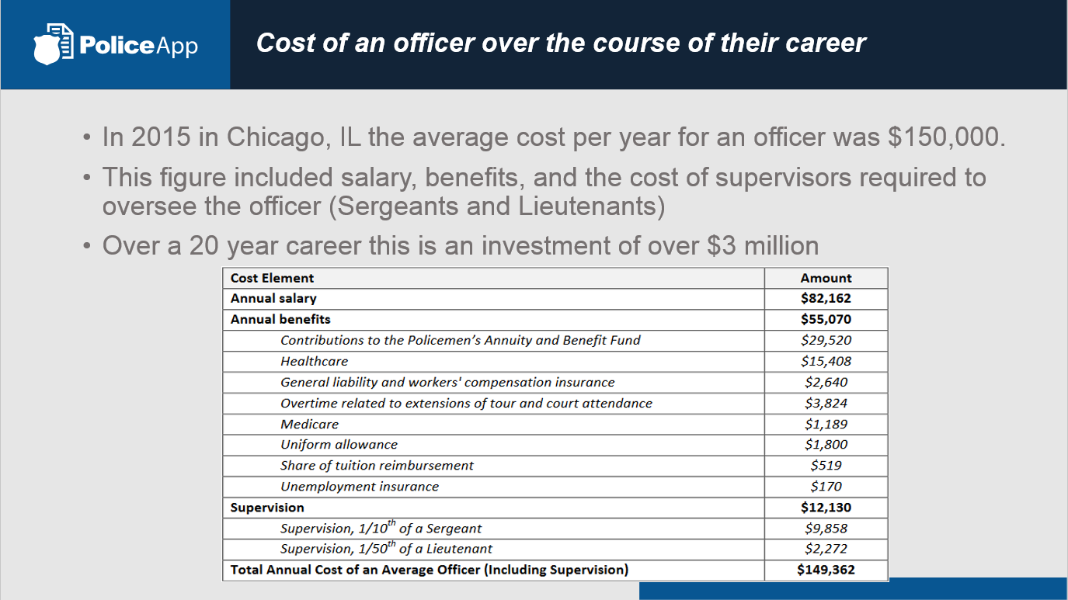

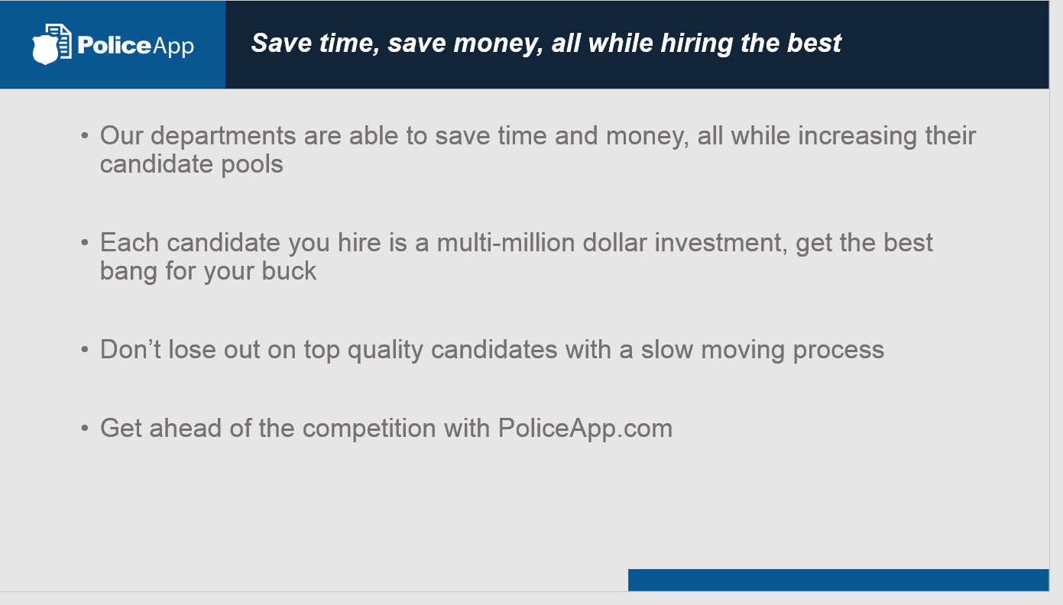

 |  | Cost to Agency/City
Applicant Funded | Applicants pays nominal fee to submit application through PoliceApp.com.  EXPLORE THE BENEFITS OF CHARGING A FEE | FREE

