CROMWELL POLICE
DEPARTMENT

Denise Lamontagne
Chief of Police
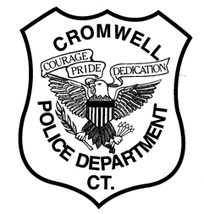
MINIMUM QUALIFICATIONS FOR POSITION OF CERTIFIED POLICE OFFICER FOR THE TOWN OF CROMWELL, CT:

- MUST BE AT LEAST 20 YEARS OF AGE AT TIME OF TESTING AND 21 YEARS OLD AT TIME OF APPOINTMENT.

- MUST POSSESS AT LEAST A HIGH SCHOOL DIPLOMA OR G.E.D. EQUIVALENT.

- HAVE NO PAST FELONY, A OR B MISDEMEANOR OR DOMESTIC VIOLENCE CONVICTIONS, OR HAVE COMMITTED ANY ACT WHICH WOULD CONSTITUE PERJURY OR FALSE STATEMENT.

- CANDIDATES MUST POSSESS A VALID POSTC CERTFICATION (MUST BE BEYOND THE TWO YEARS OF CERTIFICATION DATE AT TIME OF HIRING), OR ABLE TO OBTAIN A POST CAMPARATIVE CERTIFICATION.

- MUST PASS A DRUG SCREENING.

- MUST SUBMIT TO POLYGRAPH EXAMINATION.

- MUST SUBMIT TO PSYCHOLOGICAL EXAMINATION.

- MUST SUBMIT TO MEDICAL PHYSICAL EXAMINATION THAT MAY INCLUDE STRESS TEST.

- THE CHIEF OF POLICE HAS THE SOLE DISCRETION AND AUTHORITY TO DETERMINE A CANDIDATE NOT BE HIRED BECAUSE OF TATTOO’S/BODY ART/BRANDING.

- MUST BE NON-SMOKER.

- MUST POSSESS CONNECTICUT DRIVER’S LICENSE WITH GOOD DRIVING HISTORY.

Denise Lamontagne
Chief of Police

