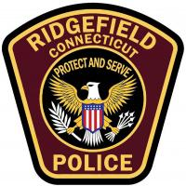
RIDGEFIELD POLICE DEPARTMENT

Eligibility

To become a Ridgefield Police Officer, candidates must meet the requirements described below as well as those of the Police Officer Standards and Training Council (POSTC).

General Requirements:
- U.S. Citizen
- High School Diploma or G.E.D.
- Valid Motor Vehicle Operator License
- 21 years old at time of appointment
- No felony, class A or Class B convictions
- No domestic violence convictions
- No perjury or false statement
- Applicant must not have been dismissed from any law enforcement unit for malfeasance or other serious misconduct.
- Applicant must not have resigned or retired from any law enforcement position while under investigation for any malfeasance or misconduct.
- Successful completion of the following:
  - (CPCA) Written Examination
  - CHIP (Physical Fitness Test)
  - Ridgefield Police Administrators’ Examination
  - Ridgefield Police Commission Oral Examination
  - Medical Examination (Including screening for use of illegal drugs or controlled substances)
  - Eye Examination
  - Psychological Evaluation
  - Polygraph Examination
  - Background Investigation
- Completion of CT Police Academy (6 months)
- Completion of Field Training Program (400 hours min.)

