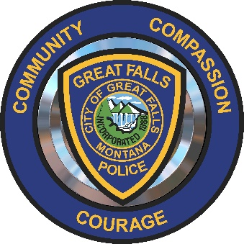
Great Falls Police Department
Montana

TATTOO POLICY NOTICE for Police Applicants

The Great Falls Police Department has a policy related to tattoos and body art. Applicants considering employment are to be aware that this policy will have a direct impact on eligibility for hiring.

Tattoos (aka body art) or branding displaying the following are prohibited at ALL times:
- Racism;
- Sexism or sexually suggestive/explicit;
- Obscenity or profane;
- Gang or drug related;
- Extremist content;
- Undermining City or department values;
- Political in nature.

All tattoos will be photographed and documented upon hiring.

Employees shall not have tattoos, branding or any form of body art on the hands below the wrist, fingers, face, neck above the collarbone, or ears. Those applicants or officers who have a “wedding band” tattoo on the left ring finger may be exempted, but only after review of the tattoo and approval from the Chief of Police.

Tattoos not prohibited by this policy are not required to be covered while employed with the Great Falls Police Department.

Body Piercing and Disfigurements:

Body piercing and intentional (decorative) disfigurement are prohibited from view while on duty. Female officers may wear a single pair of stud earrings, of modest design, in the lobe only.

